**ITEC2120 DB Design & SQL**

**SQL Lab #1**

**15 points possible**

### Northwind Database

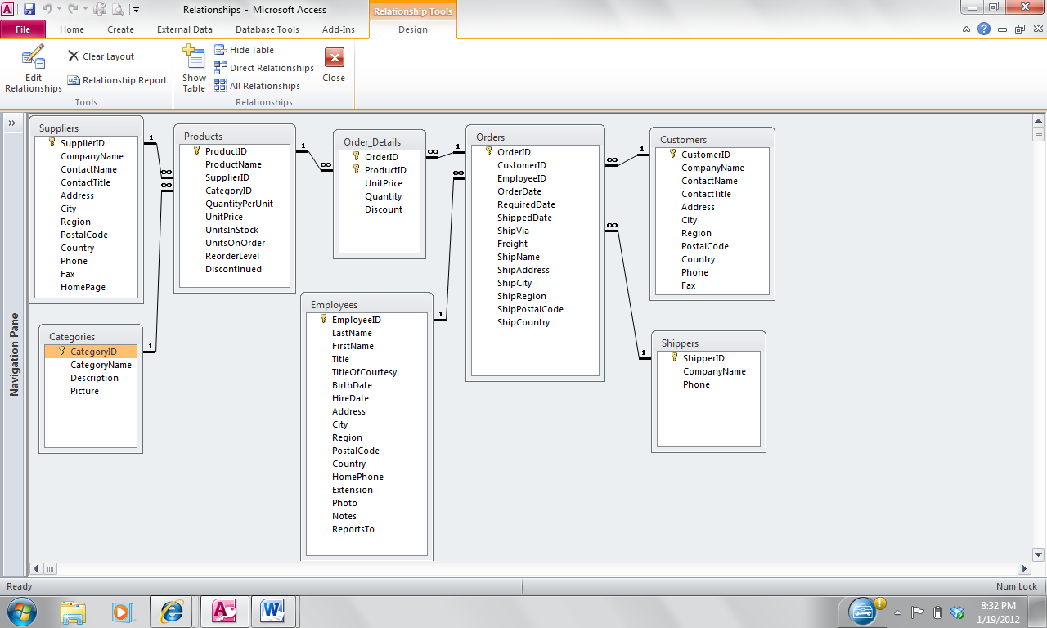

|  |  |  |
| --- | --- | --- |
| Table Name | Primary Keys | Foreign Keys |
| Categories | CategoryID | None |
| Customers | CustomerID | None |
| Employees | EmployeeID | None |
| Order_Details | OrderId, ProductID | OrderID, ProductID |
| Orders | OrderID | CustomerID, EmployeeID, ShipVia |
| Products | ProductID | SupplierID,CategoryID |
| Shippers | ShipperID | None |
| Suppliers | SupplierID | None |

Identify the relationship for each pair of tables

* One-to-One – 1:1; One to Many - 1:N; Many to Many - M:M; or None

## Northwind Database

|  |  |  |
| --- | --- | --- |
| Table 1 | Table 2 | Relationship |
| Categories | Products | 1:M |
| Customers | Orders | 1:M |
| Products | Orders | M:M |
| Supplier | Orders | None |
| Orders_Details | Orders | M:1 |